SIMATS ENGINEERING (SAVEETHA SCHOOL OF ENGINEERING)
Department of Artificial Intelligence and Data Science
ASSESSMENT TOOL 3 – CODING CHALLENGE

Course Code: | DSA03 | Course Title: | Natural Language Processing
CO Assessed: | CO1 – Imitation (L1) | Assessment: | Assessment Tool 3 – Coding Challenge
Weightage: | 30% of CIA
CO5 Statement: | Analyse NLP models, regular expression patterns, finite state automata, morphological processing techniques and to interpret language processing. (BL-3)
Student Name: | Lokeshwara H | Reg. No.: | 192325120
Section / Batch: | 2023 | Date:

Code of Conduct
I Lokeshwara H / 192325120 (Name / Reg No) certify that this submission is my original work and that I have adhered to the guidelines specified for this assessment. I understand that any violation of academic integrity rules will result in disciplinary action.
Signature of the Student: Lokeshwara H

Instructions
- Develop a complete and modular Python program that meets all the functional requirements specified in the coding challenge using appropriate algorithms, data structures, and programming practices.
- Test the program using multiple valid and invalid test cases, and clearly display the input, processing, and output to verify the correctness of the implementation.
- Follow standard coding practices by using meaningful variable names, proper indentation, comments, exception handling (where applicable), and upload the source code, sample outputs, and README file to the designated GitHub repository.
- Duration: 40 minutes.

Section / Topic | Focus | Q Nos
Porter Stemmer | class design, methods, encapsulation, and rule-based stemming | 1

Annexure A – Coding Challenge
Section 1: Object-Oriented Implementation of a Porter Stemmer
You have recently joined an NLP startup called LexiMind Technologies. The company is developing a search engine for a digital library containing millions of research papers. Users expect the search engine to return relevant results even when different grammatical forms of a word are used.
For example, a search for connect should also retrieve documents containing connected, connecting, connection, and connections. To achieve this, the development team has decided to implement the Porter Stemming Algorithm from scratch.
Since the algorithm consists of multiple sequential rules (Step 1a, Step 1b, Step 1c, Step 2, Step 3, Step 4, Step 5a, and Step 5b), the project manager has divided the work among team members. Each developer is responsible for implementing and testing one specific rule. At the end of the project, all modules must be integrated into a single, fully functional stemmer.
Assessment Task
Phase 1: Individual Task (Assigned Rule)
Each student will be assigned one Porter Stemmer rule.
Your responsibilities are to:
- Study and understand the assigned rule.
- Explain the linguistic purpose of the rule.
- Describe the conditions under which the rule should be applied.
- Implement the rule in Python.
- Prepare at least 10 test words demonstrating:
  - Words that satisfy the rule.
  - Words that should remain unchanged.
- Document the input, expected output, and actual output.
- Explain any limitations or special cases encountered.
Phase 2: Team Integration
As a team, integrate all individual rule implementations into a complete Porter Stemmer.
The team must:
- Arrange the rules in the correct execution order.
- Resolve conflicts between rule implementations.
- Ensure that the output of one rule becomes the input to the next rule.
- Test the complete algorithm using at least 50 different English words.
- Compare the team's results with the NLTK Porter Stemmer.
- Identify and explain any differences.
Phase 3: Reflection
Prepare a report addressing the following questions:
- Why is the order of Porter Stemmer rules important?
- What errors would occur if your assigned rule were skipped?
- How did integrating multiple rules improve stemming accuracy?
- Which rule was the most challenging to implement and why?
- What improvements would you suggest for the Porter Stemming algorithm?

Rubrics for Calculation
Criteria | Weightage | Level 4 – Exemplary | Level 3 – Proficient | Level 2 – Developing | Level 1 – Beginning
Problem Understanding | 20% | Clearly understands problem constraints, edge cases, and competitive requirements | Understands problem with minor gaps in constraints | Partial understanding; misses key constraints | Misinterprets problem or constraints
Algorithm | 25% | Selects optimal algorithm with best time and space complexity for competitive constraints | Uses efficient algorithm with minor scope for improvement | Uses basic/inefficient approach | No clear algorithmic approach
Code Implementation | 20% | Writes correct, efficient, and clean code that passes all constraints | Code works with minor errors or inefficiencies | Partially correct code; fails for some cases | Code does not execute or gives incorrect results
Competitive Performance | 20% | Solves problem within time limits and handles large inputs effectively | Solves within acceptable time with minor delays | Struggles with time limits or larger inputs | Unable to solve within time constraints
Test Case Handling | 15% | Handles all test cases including edge and hidden cases | Handles most test cases | Misses important edge cases | Fails on multiple test cases

Q. No. / Criteria | Problem Understanding | Algorithm | Code Implementation | Competitive Performance | Test Case Handling | Total %
1 | 20 | 25 | 20 | 15 | 12 | 92

Faculty In-charge | Course Coordinator | Program Director
Dr.T.Kumaragurubaran
Signature: _______________ | Signature: _______________ | Signature: _______________
Date: ___________________ | Date: ___________________ | Date: ___________________

Problem Statement
In Natural Language Processing (NLP), the same root word can occur in different grammatical and derived forms. This may affect applications such as search engines and information retrieval systems, where related forms of a word should be treated similarly.
The Porter Stemming Algorithm is a rule-based stemming technique that reduces English words by applying a sequence of suffix transformation rules. In this assessment, the assigned task is to implement Step 3 of the Porter Stemmer using Python.
Step 3 performs further suffix reduction by identifying specific suffixes such as -icate, -ative, -alize, -iciti, -ical, -ful, and -ness. The appropriate suffix is removed or replaced only when the stem satisfies the Porter measure condition m > 0.
The objective is to design a modular Python implementation that correctly applies the Step 3 rules, preserves words that do not satisfy the required conditions, and demonstrates the implementation using valid and unchanged test cases.

Objective
The main objective is to implement Step 3 of the Porter Stemming Algorithm from scratch using Python. The program identifies specific suffixes in an input word and performs the corresponding removal or replacement when the required Porter measure condition m > 0 is satisfied.

Linguistic Purpose of Step 3
Step 3 is used to perform further suffix reduction on words after the earlier stages of the Porter Stemmer have been applied. It mainly handles derivational suffixes that change the form or grammatical category of a word.
The Step 3 rules are:
Suffix | Replacement
-icate | -ic
-ative | Removed
-alize | -al
-iciti | -ic
-ical | -ic
-ful | Removed
-ness | Removed
For example:
triplicate → triplic
formalize → formal
hopeful → hope
goodness → good
These transformations help normalize different derived word forms into simpler stems, which is useful in NLP applications such as information retrieval, text processing, indexing, and search engines.

Conditions for Applying Step 3
In the Porter Stemming Algorithm, a Step 3 suffix cannot be removed or replaced simply because it occurs at the end of a word. The transformation is performed only when the stem satisfies the measure condition m > 0.
The measure m represents the number of vowel-consonant (VC) sequences present in the stem.
In this representation:
- V represents a vowel: a, e, i, o, u
- C represents a consonant
- The letter y is handled separately according to its position in the word.
For example, consider the word hopeful.
- The suffix ful is identified.
- Removing ful gives the stem hope.
The consonant-vowel pattern of hope is:
- h o p e
C V C V
- The stem contains one complete VC sequence, therefore m = 1.
- Since m > 0, the rule FUL → "" is applied.
- The resulting word is hope.
Therefore:
hopeful → hope
The general condition for Step 3 can be represented as:
(m > 0) suffix → replacement
If no Step 3 suffix is found, or if the stem does not satisfy m > 0, the input word remains unchanged.

Algorithm – Porter Stemmer Step 3
Input: An English word
Output: Word after applying the Porter Stemmer Step 3 rule
Start.
Read the input word and convert it to lowercase.
Define the Step 3 suffix replacement rules:
icate → ic
ative → ""
alize → al
iciti → ic
ical → ic
ful → ""
ness → ""
Check whether the input word ends with any of the Step 3 suffixes.
If a matching suffix is found, remove the suffix temporarily to obtain the stem.
Calculate the Porter measure m of the stem by counting its vowel-consonant (VC) sequences.
Check whether m > 0.
If m > 0, replace the matched suffix with its corresponding replacement.
If m = 0, leave the word unchanged.
If no Step 3 suffix is found, leave the word unchanged.
Display the resulting word.
Stop.

Pseudocode
START
INPUT word
CONVERT word to lowercase
DEFINE Step 3 rules:
ICATE → IC
ATIVE → empty
ALIZE → AL
ICITI → IC
ICAL → IC
FUL → empty
NESS → empty
FOR each suffix and replacement
IF word ends with suffix THEN
stem = word without suffix
CALCULATE measure(stem)
IF measure(stem) > 0 THEN
word = stem + replacement
END IF
BREAK
END IF
END FOR
OUTPUT word
STOP

Python Implementation – Porter Stemmer Step 3

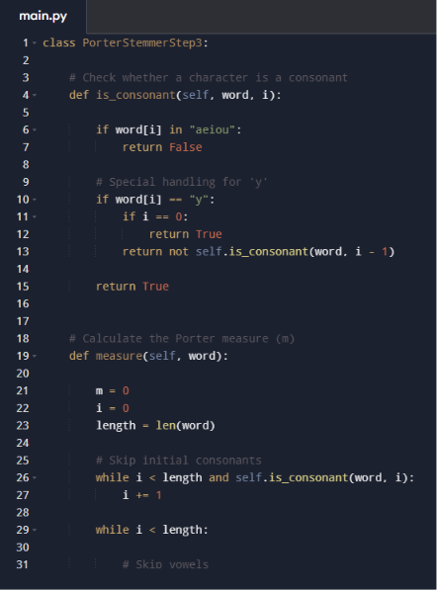
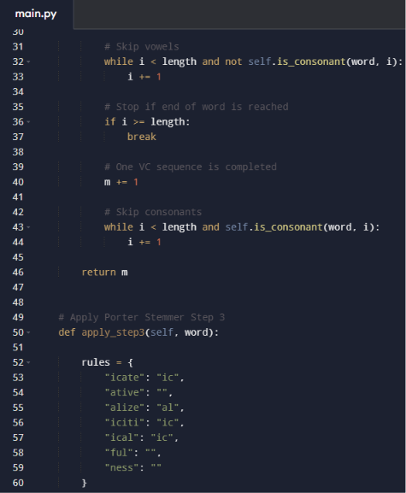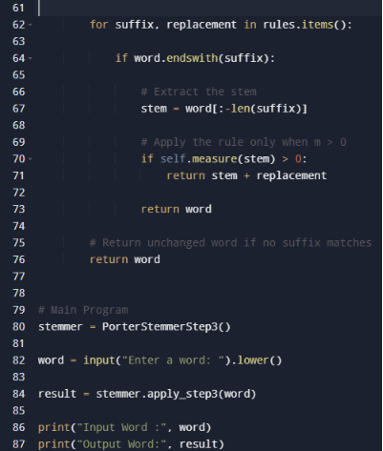

Test Cases – Porter Stemmer Step 3
The program was tested using words covering all seven Step 3 suffix transformation rules, along with words that should remain unchanged.
Test No. | Input Word | Rule Applied | Expected Output | Actual Output | Status
1 | triplicate | icate → ic | triplic | triplic | Pass
2 | formative | ative → "" | form | form | Pass
3 | formalize | alize → al | formal | formal | Pass
4 | electriciti | iciti → ic | electric | electric | Pass
5 | electrical | ical → ic | electric | electric | Pass
6 | hopeful | ful → "" | hope | hope | Pass
7 | goodness | ness → "" | good | good | Pass
8 | cat | No matching Step 3 suffix | cat | cat | Pass
9 | running | No matching Step 3 suffix | running | running | Pass
10 | computer | No matching Step 3 suffix | computer | computer | Pass
11 | beautiful | ful → "" | beauti | beauti | Pass
12 | happiness | ness → "" | happi | happi | Pass

Test Case Categories
Words satisfying Step 3 rules:
triplicate, formative, formalize, electriciti, electrical, hopeful, goodness, beautiful, and happiness.
Words remaining unchanged:
cat, running, and computer.
These unchanged words demonstrate that the program does not modify an input when no Step 3 suffix matches.

Sample Output
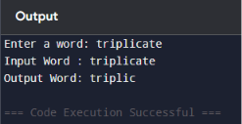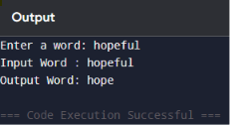
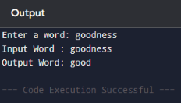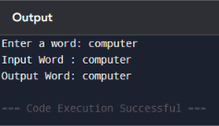

Conclusion on Limitations
Porter Stemmer Step 3 provides a simple and computationally efficient method for reducing selected derivational suffixes. However, it is most effective when executed in the correct sequence with the remaining Porter Stemmer rules.

Time and Space Complexity
Let n represent the number of characters in the input word.

Time Complexity
The Step 3 implementation checks the input word against a fixed set of seven suffix rules. The measure() method scans the stem character by character to identify vowel-consonant (VC) sequences.
Since the number of Step 3 suffix rules is constant and the word is processed linearly, the overall time complexity is:
Time Complexity: O(n)
where n is the length of the input word.

Space Complexity
The Step 3 suffix rules are fixed in size. Apart from the input word, stem, and a few variables used for processing, no data structure grows significantly with the size of the input.
The implementation therefore requires only a small amount of additional working memory.
Auxiliary Space Complexity: O(n) in this Python implementation because operations such as slicing the word to create the stem can create a new string of length proportional to the input.

Performance
The algorithm is efficient because:
Only seven Step 3 suffix rules are checked.
The input word is processed using simple string operations.
The measure calculation requires a linear scan of the stem.
No external NLP library is required.
The implementation can efficiently process words of different lengths.
Therefore, the Step 3 implementation is suitable for integration into the complete Porter Stemming Algorithm and for processing large collections of text.

Phase 3 – Reflection

1. Why is the order of Porter Stemmer rules important?
The order of the Porter Stemmer rules is important because the algorithm works sequentially. The output generated by one step becomes the input to the next step. Earlier steps may modify a word so that it satisfies the conditions of a later step.
Therefore, changing the order of the rules may cause a suffix to be removed too early, prevent another rule from being applied, or produce an incorrect stem. The correct order is:
Step 1a → Step 1b → Step 1c → Step 2 → Step 3 → Step 4 → Step 5a → Step 5b

2. What errors would occur if Step 3 were skipped?
If Step 3 were skipped, words containing suffixes such as -icate, -ative, -alize, -iciti, -ical, -ful, and -ness may not undergo the intended intermediate suffix reduction.
For example, Step 3 transformations include:
triplicate → triplic
formalize → formal
hopeful → hope
goodness → good
Skipping Step 3 could therefore result in incomplete stemming and may also affect the processing performed by subsequent rules.

3. How did integrating multiple rules improve stemming accuracy?
Integrating multiple rules improves stemming because different word structures are handled by different stages of the Porter Stemmer.
For example, Step 1 processes plural and verb-related endings, Step 2 and Step 3 perform suffix transformations, Step 4 removes additional suffixes, and Step 5 performs final cleanup.
By combining all these rules in the correct sequence, the stemmer can process a much wider variety of English word forms than any individual rule can handle independently.

4. Which rule was the most challenging to implement and why?
Step 4 can be considered one of the most challenging rules because it contains several possible suffix removals, uses the stricter measure condition m > 1, and includes special handling for the suffix -ion.
The implementation must correctly identify the suffix, calculate the measure of the stem, and verify all required conditions before modifying the word. This makes Step 4 more condition-dependent than many of the other stages.

5. What improvements would you suggest for the Porter Stemming Algorithm?
The Porter Stemmer can be improved by combining rule-based stemming with additional linguistic information. Possible improvements include better handling of irregular words, exception lists, and dictionary-based validation.
The algorithm could also be extended to consider the grammatical role or context of a word before applying transformations. For applications where valid dictionary base forms are important, lemmatization can be used instead of, or together with, stemming.
These improvements could reduce overstemming and understemming while producing more linguistically meaningful word forms.

